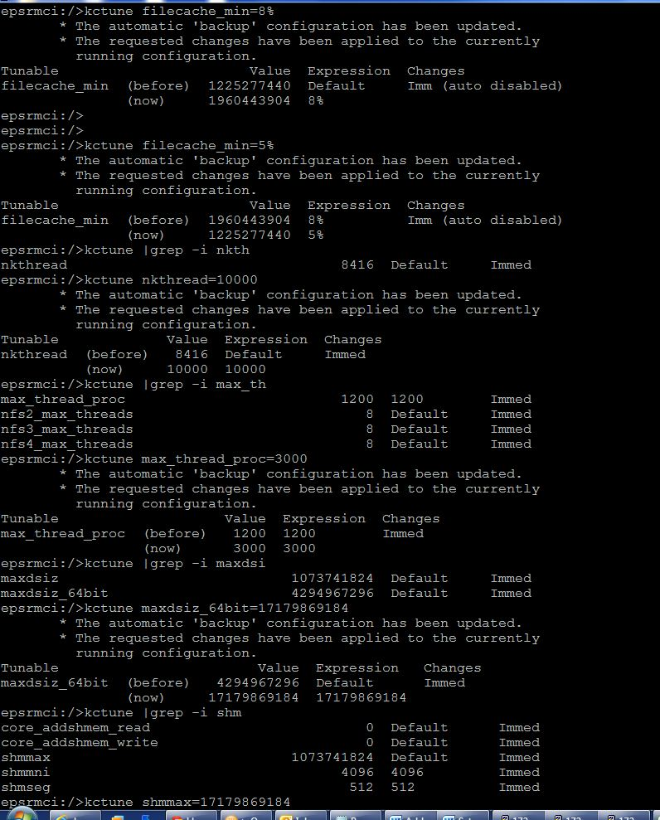

Change oracle installation required kernel parameter